**GENERAL INTEGRATED SCIENCE – UNIT 4**

**TASK 10 – CHEMICAL REACTIONS TEST**

**MARKING KEY /35**

***Time = 55 minutes***

1. Match the following functional properties of food with their correct definition. (5 marks)

|  |  |  |
| --- | --- | --- |
| **Coagulation** | **Dextrinisation** | **Caramelisation** |
| **Aeration** | **Gelatinisation** |  |

1. **Gelatinisation**
2. **Aeration**
3. **Coagulation**
4. **Caramelisation**
5. **Dextrinisation**
6. During cooking, ingredients either stay the same or help to form new products. In the questions below c*ircle the correct type of change.* (3 marks)
   1. Melting chocolate (from a solid to a liquid state) is an example of:

***PHYSICAL CHANGE or CHEMICAL CHANGE***

* 1. Baking a dough mixture to form scones:

***PHYSICAL CHANGE or CHEMICAL CHANGE***

* 1. Popping corn kernels

***PHYSICAL CHANGE or CHEMICAL CHANGE***

1. Little Johnny decided to make his mum bacon and eggs in bed on Christmas morning when all the shops in town were closed. He only had two (2) eggs and decided to fry the both of them along with the bacon. His mother did not eat both eggs, only one (1).
   1. Would he be able to re-use that uneaten egg to make her a cake later in the day? Respond to this in the context of food chemistry and NOT in reference to hygiene.

(1 mark)

**YES** or **NO**

* 1. Justify your response and explain why you can or cannot re-use the egg. (3 marks)
* Chemical change / new product formed (1)

Any 2 points

* Egg separate to rest of cake (1)
* Colour change – egg white goes clear to white (1)
* Liquid to solid (1)

1. Define the following terms:
   1. Reactant(1 mark)

* What is used in a reaction / goes into a reaction (1)
  1. Product (1 mark)
* What is produced in a reaction / products of a reaction (1)
  1. Catalyst (2 marks)
* A substance that increase the rate of a chemical reaction (1) without itself being used up (1)

1. Below is an incomplete word equation

a.

* Sodium carbonate + carbon dioxide + water
  1. What is/are the missing reactants in this equation? (1 mark)
* Sodium bicarbonate / baking soda (1)
  1. This is an example of what type of reaction? (1 mark)
* Decomposition (1)
  1. Does this reaction absorb or release heat? (1 mark)
* Absorb (1)
  1. In which of the following diagrams would you use the previous equation. Circle the correct diagram. (2 marks)

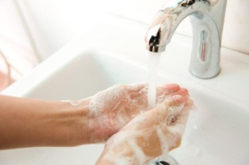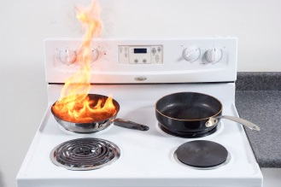

OR

1. In the food production process there are many chemical reactions that occur. Use the picture below to answer the following questions.

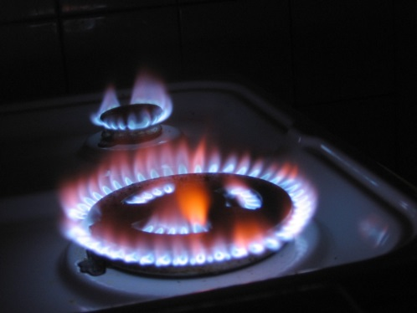

* 1. What reaction type is being represented in the picture of a gas stove top? (1 mark)
* Combustion (1)
  1. Is it absorbing or releasing energy? (1 mark)
* Releasing (1)
  1. Is your response to part (ii) described as exothermic or endothermic? (1 mark)
* Exothermic (1)
  1. State a simple word equation that describes the reaction taking place. (2 marks)

Methane + Oxygen (1) 🡪 Carbon dioxide + water [+ heat] (1) *accept with or without heat*

1. Protein is a large organic molecule that can be found in many food products. A protein is made-up of smaller units called amino acids. The way the amino acids attach to each other give protein a three dimensional (3D) shape.

Below are two diagrams showing how the protein, Gluten, changes shape during the dough making process.

 (A) (B)

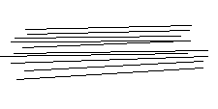

1. What is (A)? (1 mark)

* Gluten (1)

1. What is (B)? (1 mark)

* Network Strands

1. Explain the process that takes place to allow this shape change from a three dimensional (3D) structure to network strands. (2 marks)

* Kneading / Denature (1)
* Kneading allows gluten network to be formed / create elasticity (1)

*Any correct response that explains ‘HOW’ is acceptable.*

1. To make ice-cream, most people use an ice-cream machine. However this is not the only way to make ice-cream. Answer the following questions
2. Briefly write a **method** of how to make ice-cream without a machine. (3 marks)

* Third person (1)
* Correct method (1)
* Correct format (1)

1. Why do we add salt to ice? (2 marks)

* Lowers freezing point of ice (1)
* Melts slower and colder for longer (1)